All three URI, URL, and URN are used to identify any resource or name on the internet, but there is a subtle difference between them. URI is the superset of both URL and URN. By the way, the main difference between URL and URI is protocol to retrieve the resource. URL always include a network protocol e.g. HTTP, HTTPS, FTP etc to retrieve a resource from its location. While URI, in case of URN just uniquely identifies the resource e.g. ISBN numbers which are a good example of URN is used to identify any book uniquely.

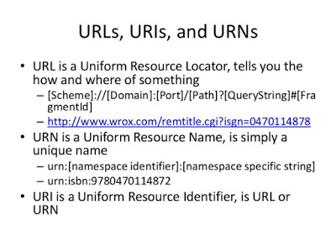

Difference between URI, URL, and URN

After knowing what is URI, URL, and URN, it's easy to find the difference between them. The main difference between URI and URL is that every URL is a URI but not vice versa. Similarly, every URN is a URI, but the opposite is not true. Another difference between URI and URL is that URL includes the protocol, which is key to retrieving information from any location. Here are few differences between URI, URL and URN in point format:

1) Every URL and URN is URI because URI is the superset of both URL and URN.
2) URL includes protocol e.g. http://, ftp:// along with location to identify resource e.g. http://www.blogspot.com/abc.html.
3) URN are the unambiguous way to identify a resource. ISBN numbers are best examples of URN.

